**HCL INTERNSHIP –MINI PROJECT**

Chilukuri Gopi

39110229

Abstract :

The Indian Railways (IR) carries about 5.5 lakhs passengers in reserved accommodationevery day. The Computerised Passenger Reservation System (PRS) facilates the booking andcancellation of tickets from any of the 4000 terminals (i.e. PRS booking window all over thecountries). These tickets can be booked or cancelled for journeys commencing in any partof India and ending in any other part, with travel time as long as 72hours and distanceupto several thousand kilometers.In the given project we will be developing a website which will help users to find traindetails, book and cancel tickets and the exact rates of their tickets to the desireddestination.With the help of online booking people can book their tickets online through internet,sitting in their home by a single click of mouse.

Languages used:

1.HTML

2.PHP

3.CSS

4.javascript

Flow Diagram:

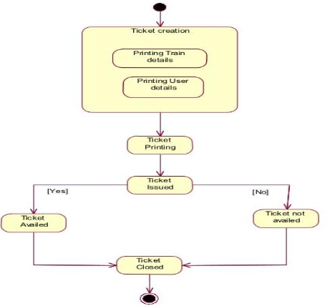

Usecase Diagram:

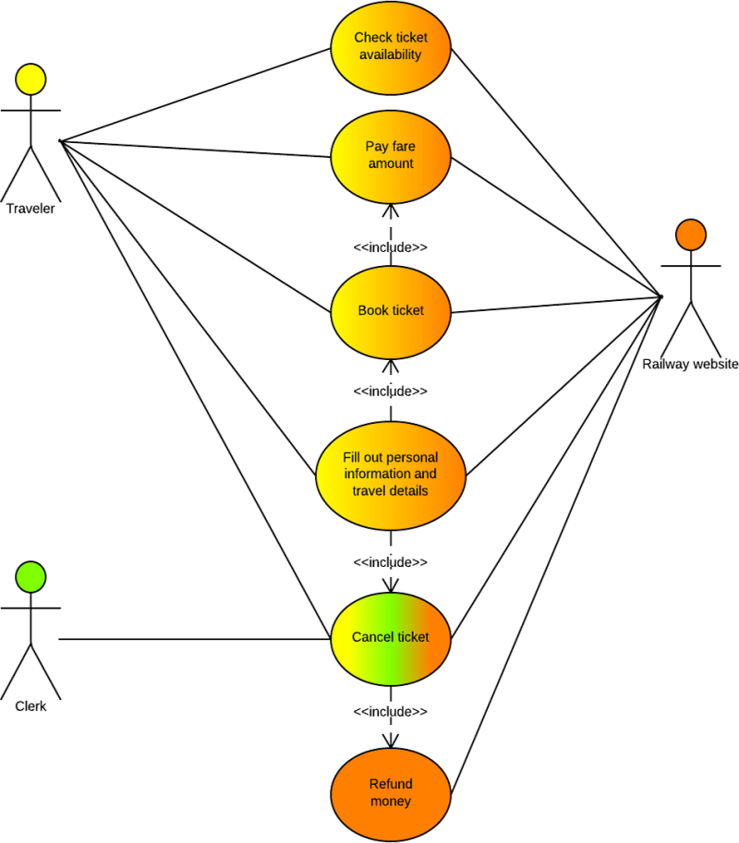

Sequence Diagram:

